# Getting Started – Updating & New Laptops (Quick List - 2025)

Log onto the Guest Wi-Fi and search the internet to download & install the latest versions of the following list of programs. If given the option: chose to install for all users on the laptop and also chose to add a shortcut to the desktop.

|  |  |
| --- | --- |
|  | 1. FRC **2025** Tools *(New* ***2025*** *Install)* |
|  | 1. WPI Library *(New* ***2025*** *Install)* |
|  | 1. WinMerge *(check for updates if already installed)* |
|  | 1. WinScp *(check for updates if already installed)* |
|  | 1. Notepad ++ *(check for updates if already installed)* |
|  | 1. VS Code *(can get with WPI Library Full Install -* *check for updates if already installed)* |
|  | 1. Rev Hardware Client *(check for updates if already installed)* |
|  | 1. Phoenix Framework for FRC (CTRE) *(check for updates if already installed)* |
|  | 1. AdvantageScope (Team 6328) – from GitHub *(check for updates if already installed)* |
|  | 1. PathPlanner – from GitHub *(check for updates if already installed)* |
|  | 1. Visual Studio Community Edition (needed for simulations), *(check for updates if already installed)*   Loading the Toolsets for:  Python (should be in the main installer)  Net Desktop Development  Desktop Development C++ |
|  | 1. 7 Zip *(check for updates if already installed)* |
|  | 1. Balena Etcher *(check for updates if already installed)* |
|  | 1. Doxygen *(check for updates if already installed)* |
|  | 1. GraphViz *(check for updates if already installed)* |
|  | 1. Git *(check for updates if already installed)* |
|  | 1. Phoenix Tuner X (CTRE) *(check for updates if already installed)* |
|  | 1. LimeLight Hardware Manager (for April tags) *(check for updates if already installed)* |
|  | 1. **\*New for 2025** – Choreo (supplements Auto with Path Planner) |

# Getting Started – Updating Laptops (Supplemental Detail)

* **FRC 2025 Tools** *(same steps as 2024)*

* **WPI Library**
  + [*WPILib Installation Guide — FIRST Robotics Competition documentation*](https://docs.wpilib.org/en/stable/docs/zero-to-robot/step-2/wpilib-setup.html)*; and select DOWNLOAD from that installer setup page*

Install Options: We did Tools only for 2024, but could just as easily do Everything

* **Tools Only** installs just the WPILib tools (Pathweaver, Shuffleboard, RobotBuilder, SysId, Glass, and OutlineViewer) and JDK.
* **Everything** installs the full development environment (VS Code, extensions, all dependencies), WPILib tools, and JDK.

Two user options: **Install for this User** and **Install for all Users**.

* + **Install for this User** only installs it on the current user account, and does not require administrator privileges. However, **Install for all Users** installs the tools for all system accounts and *will* require administrator access.
* **WinMerge**

* **WinScp**

* **Notepad ++**

* **VS Code**

* **Rev Hardware Client**

* **Phoenix Framework for FRC (CTRE)**

* **AdvantageScope (Team 6328) (Download from GitHub)**

* **PathPlanner (Download from GitHub)**

* **Visual Studio Community Edition (including the toolsets for Python, Net Desktop Development, and Desktop Development C++)**

* **7 Zip**

* **Balena Etcher**

* **Doxygen (for software documentation)**

* **GraphViz**

* **Git (64 bit for windows)**

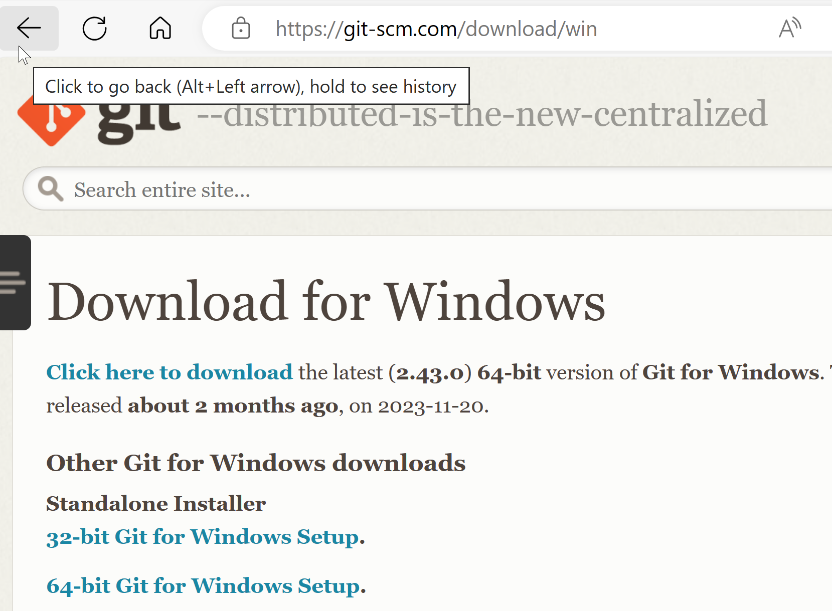

* **Phoenix Tuner X (CTRE)**

Download from Microsoft app store

* **Choreo (Git Hub)**

[***GitHub - SleipnirGroup/Choreo: A graphical tool for planning time-optimized trajectories for autonomous mobile robots in the FIRST Robotics Competition.***](https://github.com/SleipnirGroup/Choreo) ***Use in conjunction with Path Planner***

* **LimeLight Hardware Manager (needed for April tags)**

[***Downloads | Limelight Documentation***](https://docs.limelightvision.io/docs/resources/downloads)

